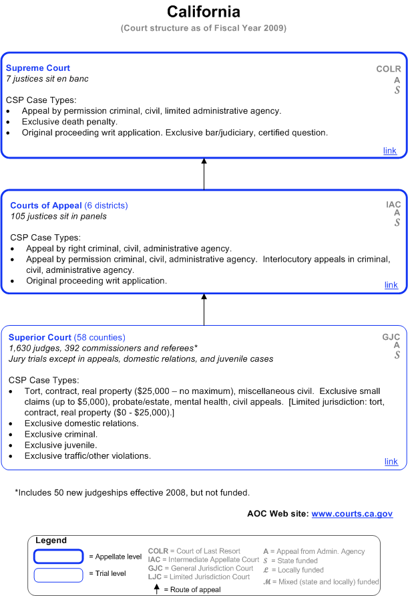

Source: http://www.courtstatistics.org/Other-Pages/State_Court_Structure_Charts/California.aspx

