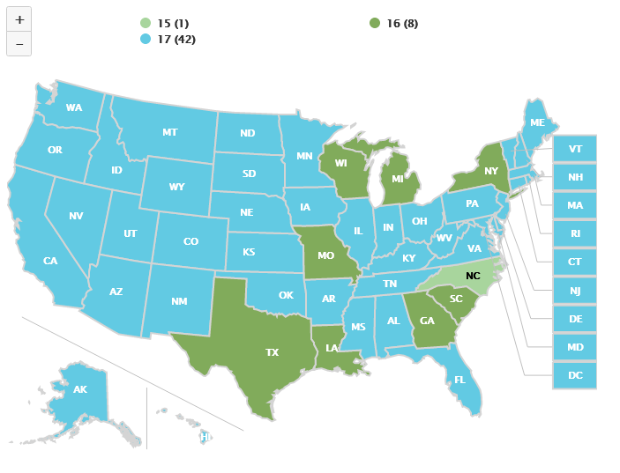

Upper Delinquency Age, 2018
Source: OJJDP Statistical Briefing Book. Online. Available: https://www.ojjdp.gov/ojstatbb/structure_process/qa04102.asp?qaDate=2018. Released on December 13, 2019.

