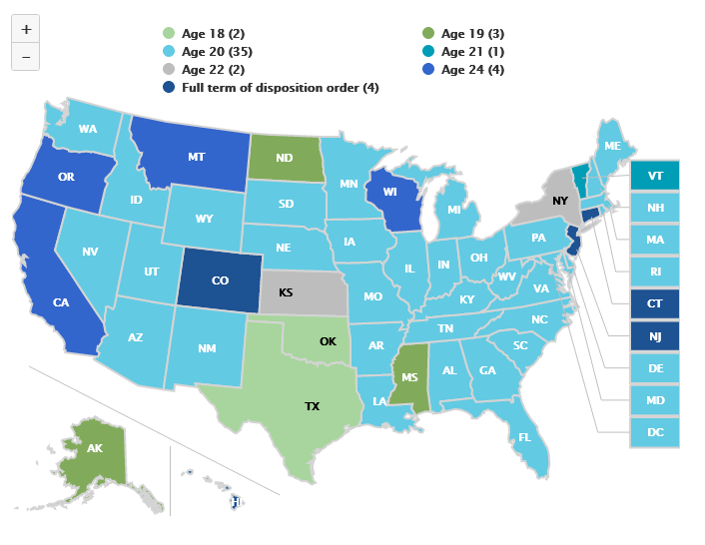

Extended Age of Juvenile Court Jurisdiction, 2018
Source: OJJDP Statistical Briefing Book. Online. Available: https://www.ojjdp.gov/ojstatbb/structure_process/qa04106.asp?qaDate=2018. Released on December 13, 2019.

