Active Learning Exercise 25.1
to accompany
Vertebrate Life, Tenth Edition
Pough • Janis

Comparing Mammalian Reproductive Investments

by Christine Dahlin
University of Pittsburgh at Johnstown
cdahlin@pitt.edu

Activity

The Dorcas gazelle (Gazella dorcas) and the wallaroo (Macropus robustus) are grazers and browsers that weigh 15-30 kg as adults.
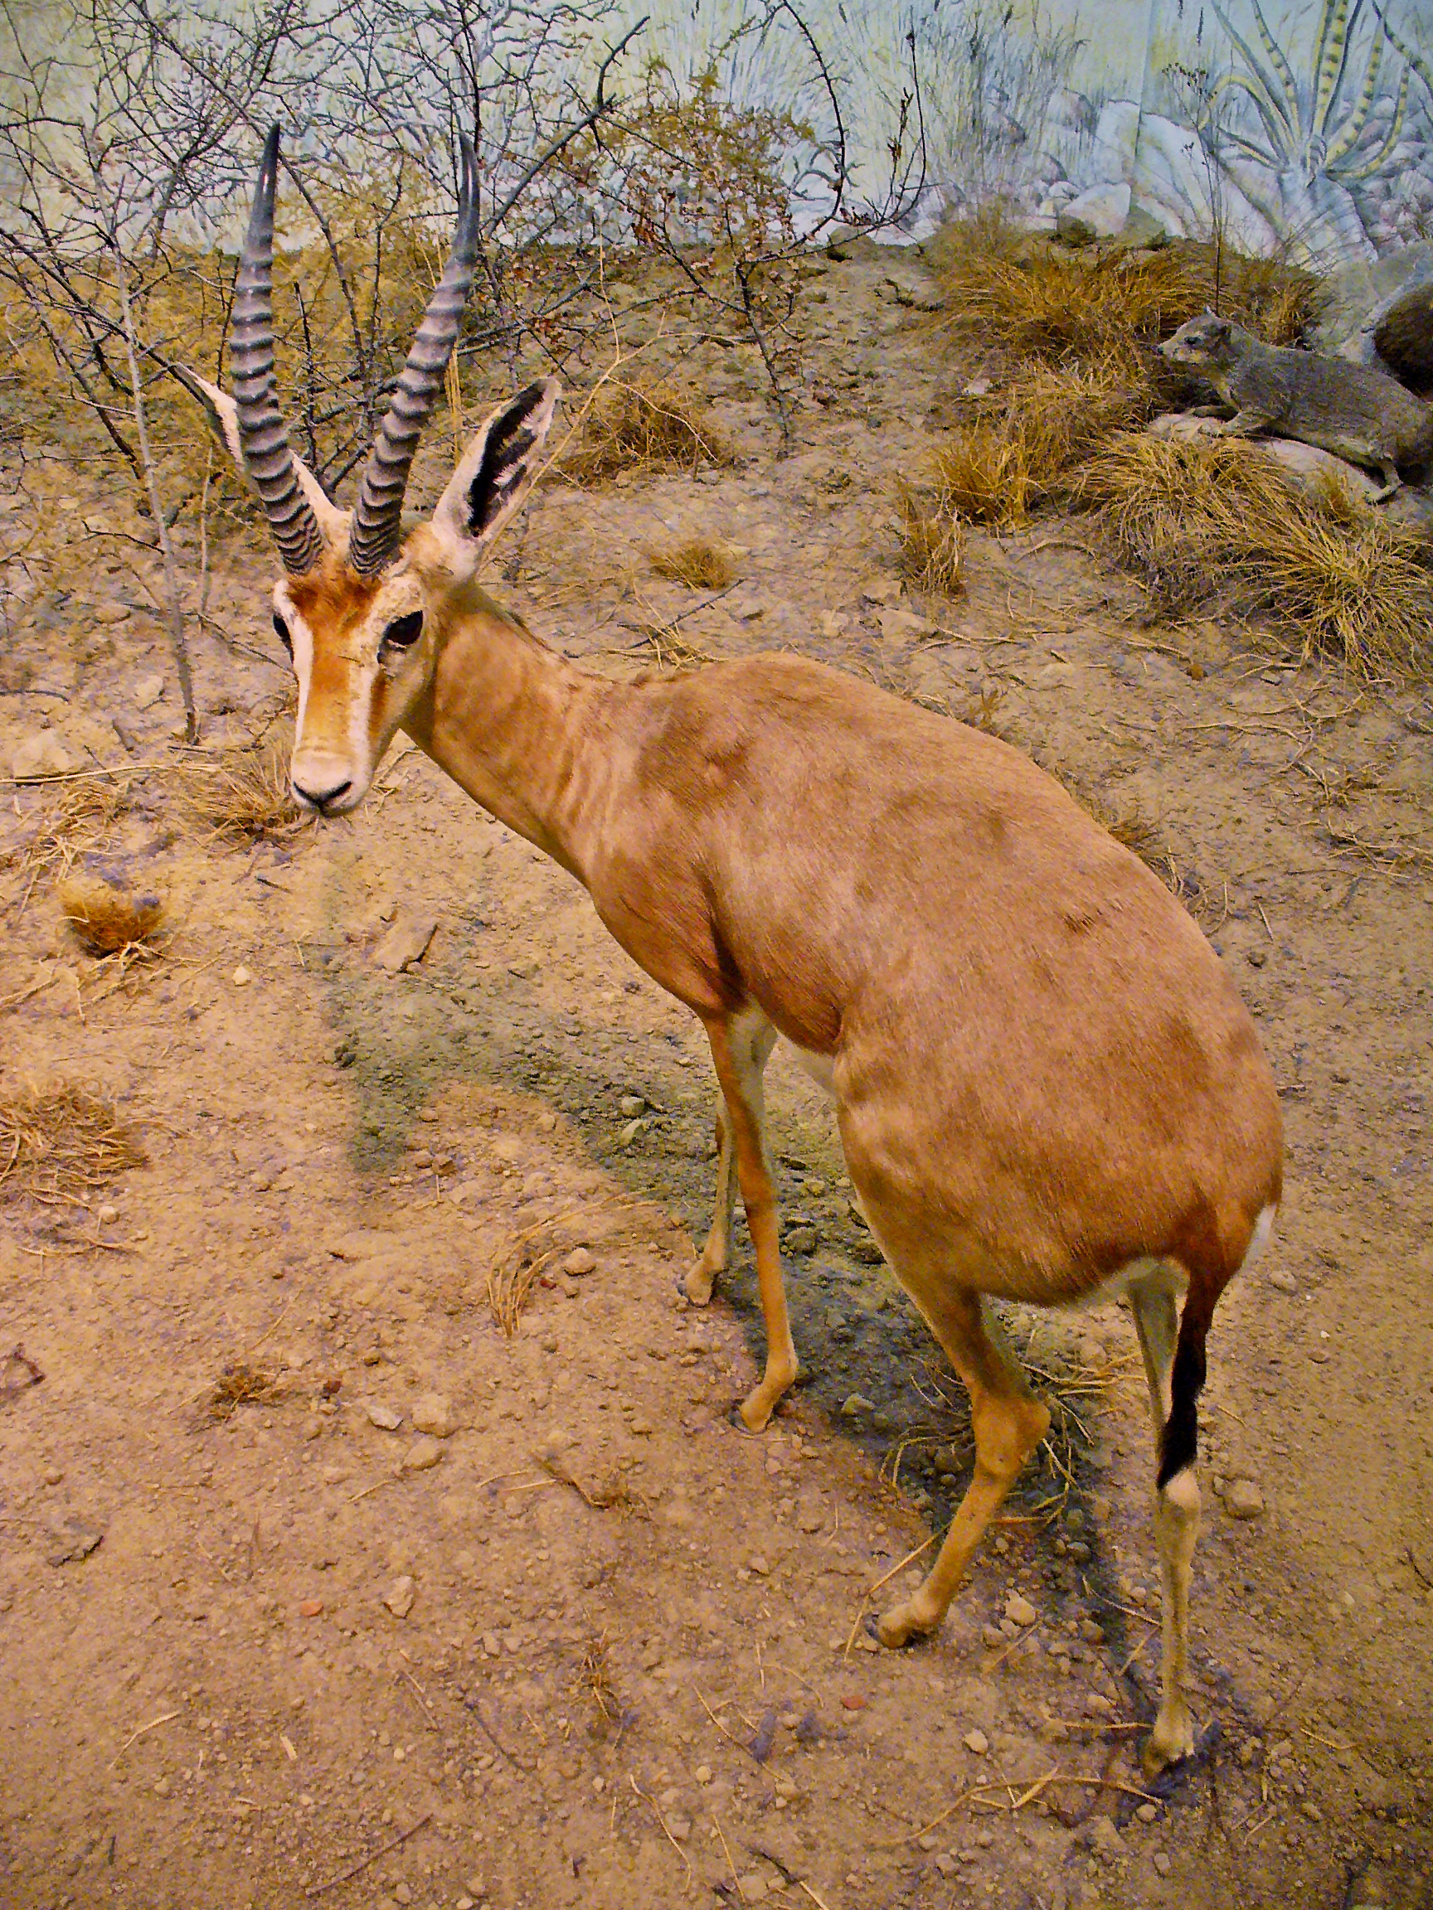

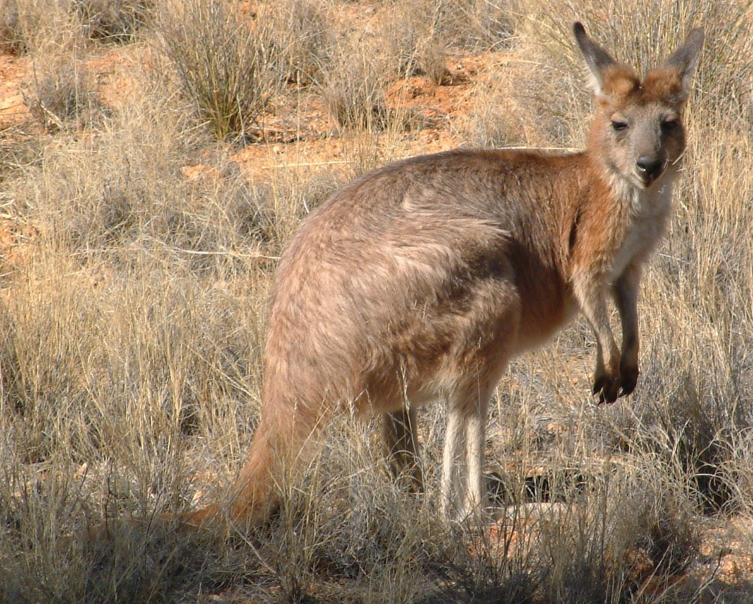

Dorcas gazelle photo by H. Zell CC BY-SA 3.0. Wallaroo photo by Michael Barritt and Karen May CC-BY-SA 2.0

Despite those similarities, they differ greatly in the timing of reproductive investment; the gazelle, a placental, has a long gestation period and a short lactation period, whereas the wallaroo, a marsupial, has a brief gestation period followed by a long period of lactation.

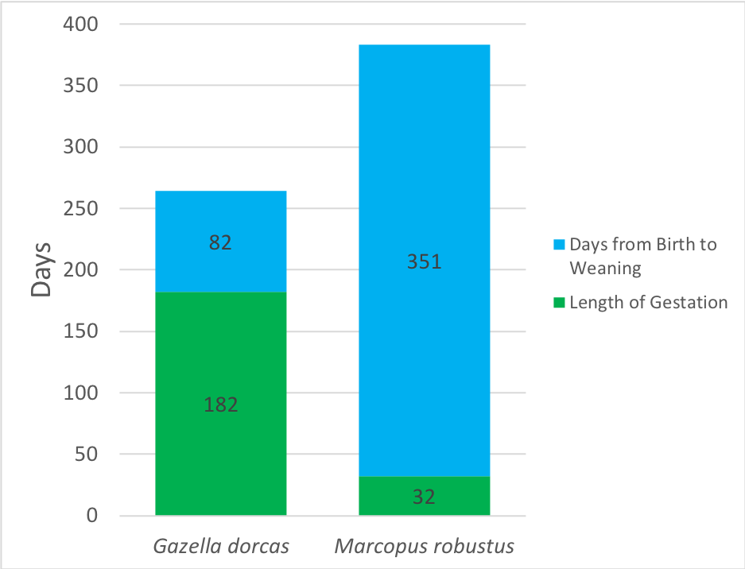

Duration of gestation and lactation. (Data from AnAge: The Animal Aging and Longevity Database http://genomics.senescence.info/species/index.html.)

1. Let’s put these data in a form that’s easier to compare: What percentage of the time from implantation to weaning is devoted to gestation and lactation by each species?

2. Now consider growth during lactation.

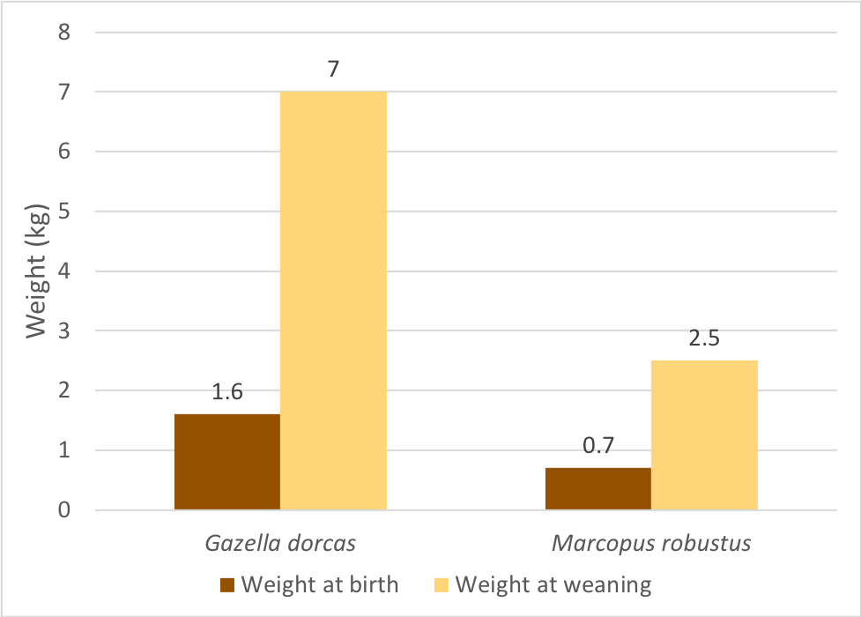

Weights at birth and weaning. (Data from AnAge: The Animal Aging and Longevity Database http://genomics.senescence.info/species/index.html.)
Which reproductive mode yields the most rapid rate of growth during lactation? (Remember to subtract birth weight from weaning weight before you calculate the rate of growth.)

Despite the major differences in the details of fetal and post-natal energy investment by placentals and marsupials, both modes have persisted since very early in the evolution of mammals, so clearly both modes are effective. Does each method have specific advantages and disadvantages? The textbook hints at some differences without getting into much detail; let’s do better.

Make a table comparing the pros and cons of each reproductive mode in hypothetical ecological contexts.
- For example, how much energy has a placental invested in her fetus at birth compared to a marsupial? Suppose the mother’s energy supply suddenly was drastically reduced by a natural disaster, such as a flood or drought—which mode of reproduction best allows a female to minimize her loss? Why is that so?
- What problems confront a lactating female placental and marsupial when she must flee at top speed to escape a pursuit predator? Which mode of reproduction gives the female the best chance of escape? Why is that so?

