Active Learning Exercise 19.1
to accompany
Vertebrate Life, Tenth Edition
Pough • Janis

Were dinosaurs warm- or cold-blooded?

by Sharon L. Gilman
Coastal Carolina University
sgilman@coastal.edu

Sources:

Seymour, RS. 2013. Maximal aerobic and anaerobic power generation in large crocodiles vs. mammals: implications for dinosaur gigantothermy. PLoS ONE 8(7): e69361. doi:10.1371/journal.pone.0069361 https://doi.org/10.1371/journal.pone.0069361

Werner, J, and EM Griebeler. 2014. Allometries of maximum growth rate versus body mass at maximum growth indicate that non-avian dinosaurs had growth rates typical of fast growing ectothermal sauropsids. PLoS ONE 9(2): e88834. doi:10.1371/journal.pone.0088834 https://doi.org/10.1371/journal.pone.0088834

Activity

Because many dinosaurs are so big and apparently active, researchers have explored the possibility that they were endothermic.

1. Why might you expect that a large animal like some of the dinosaurs would be able to maintain a body temperature above ambient? Have you seen other non-mammalian examples of that?

One way that an ectothermic animal is different than an endothermic animal is in their growth rates. Since endothermic animals are able to maintain a constant optimal temperature, regardless of habitat, they are assumed to have faster and more constant growth rates than ectotherms.

2. How could you use this assumption to test whether dinosaurs were ectotherms or endotherms?

Determining statistically comparable growth rates for even extant vertebrates is a challenge. The data you’re going to look at is based on a determination of Absolute Growth Rate (AGR) using phylogenetic generalized regression equations standardized to the body mass where maximum growth occurred (different taxa will have their maximum growth rates at different points in their life histories, corresponding to different body masses.). (Werner and Griebeler, 2014) The initial fitting of a regression to the various vertebrate groups compared is shown here in Figure 1:
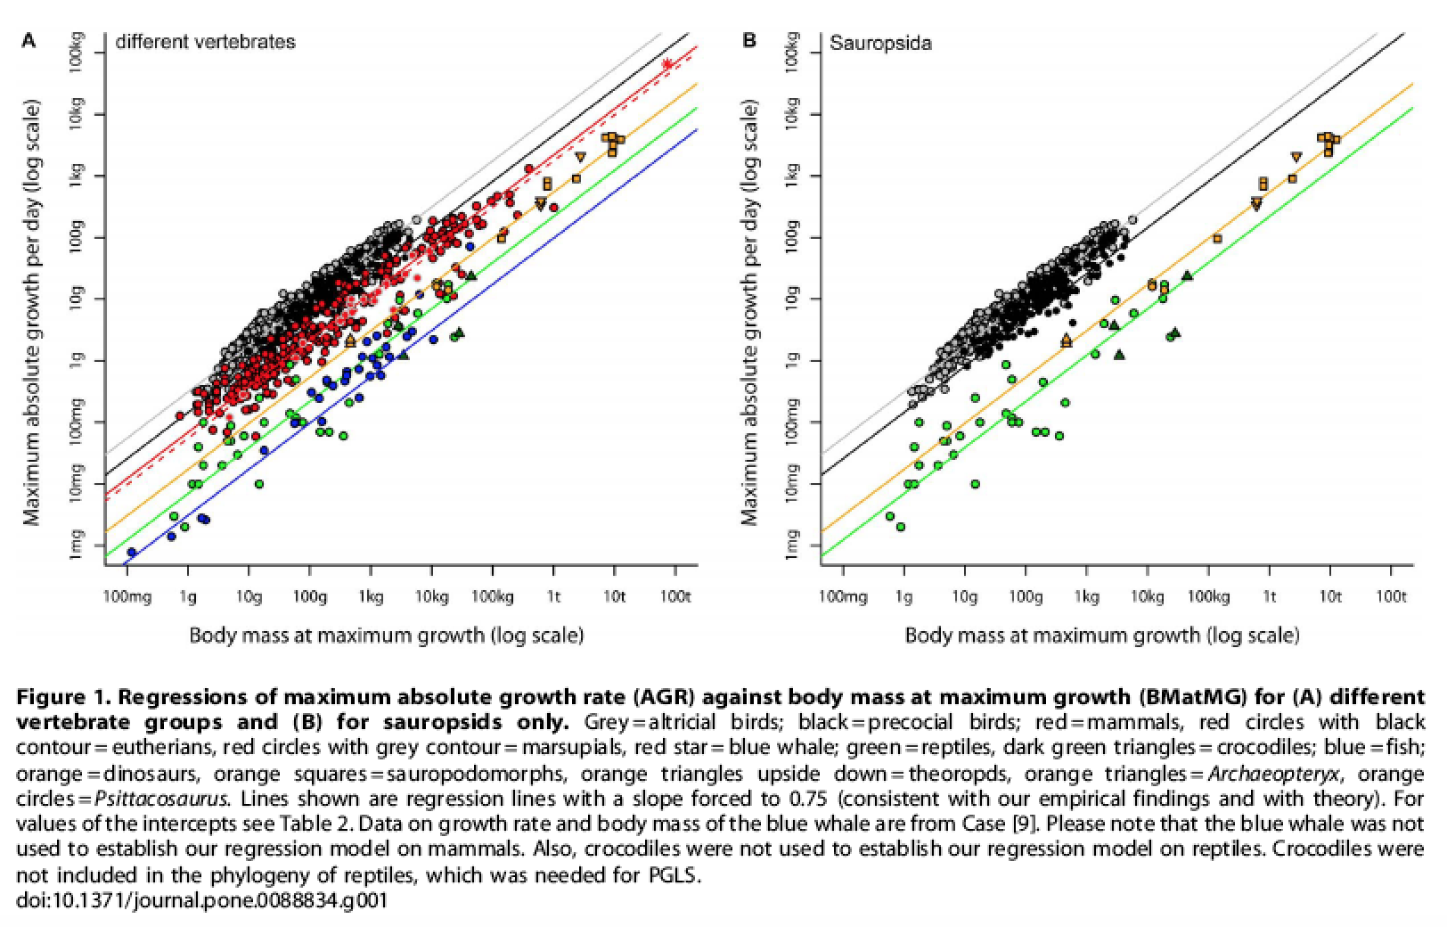

3. List which vertebrate groups are represented in these data in Fig. 1. How do the non-avian dinosaurs (sauropsids) compare to the extant vertebrates and why are these data important to this study?

Here in Fig 3 are the regression models for growth rates at body mass of maximum growth for each group examined, and the dinosaurs. They compare these to a previous study (Case, on the left). Let’s just look at the new data on the right.
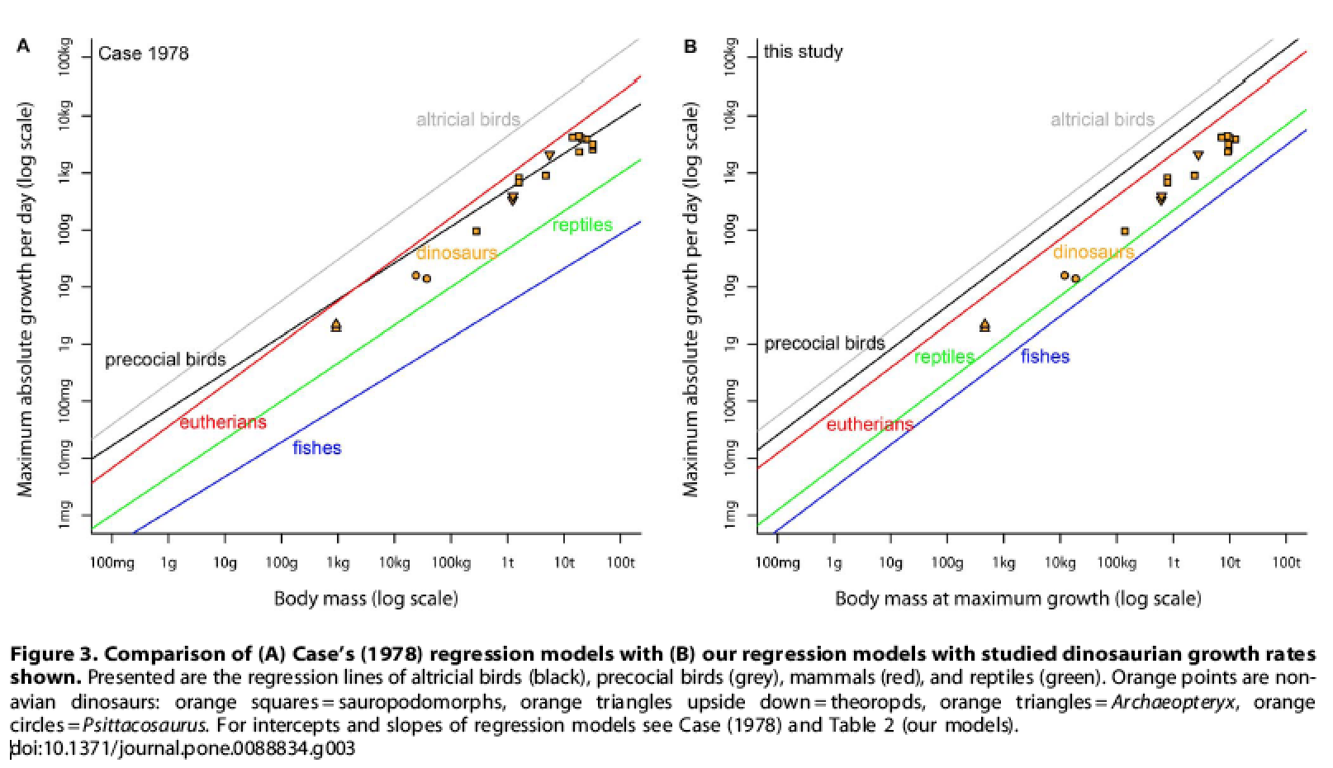

4. What can you conclude about growth rates of the non-avian dinosaurs?

One important thing here is that the range of growth rates for each group are particular to the group, meaning you can predict a typical range for a growth rate of a fish versus that of a bird, say. So the fact that the dinosaurs fall above between reptiles and mammals suggests that they are maybe not quite ectotherms, but also not quite endotherms. This is why the debate goes on.

5. In addition, temperature isn’t the only thing that affects growth, right? What other variables affect growth rate?

6. One other thing to consider: a lot of dinosaurs evidently had feathers. How might that fact relate to the ecto- vs. endothermy debate? (This will be easy to answer once you’ve read the chapter on endothermy!)

The jury is still out then on whether dinosaurs were ecto- or endothermic, but many of them were large, and so as you noted earlier, they would have been able to retain some heat like other large extant ectotherms. Would this have done them any good?

7. If you look at the simplified Diapsida cladogram in your text (Fig 16.2 in VL9), is there an ectothermic extant animal that is a close relative and might also be large enough to retain some heat and thus could serve as a model for dinosaur activity?

In fact, birds and crocodiles are extant archosaurs, phylogenetically bracketing the dinosaurs. This fact is used to infer much about dinosaurs. For example, since both birds and crocodiles have 4-chambered hearts, lungs that function with unidirectional airflow, and various other structural similarities, and share behaviors such as parental care and signaling, it’s assumed that dinosaurs shared these too. But birds have much higher metabolic rates and are endothermic, while crocodiles behaviorally thermoregulate and have low, ectothermic metabolic rates. So which way do the dinosaurs tend? So far you’ve looked at evidence from growth rates and found that the dinosaurs are perhaps more ectothermic than reptiles but less endothermic than mammals (and well below birds). Would their ability to retain heat due to size be sufficient to confer an advantage in power that might be useful in catching prey or avoiding predators? Is that the case with big crocodiles?

The Seymour (2013) study looked at this question by measuring the power and endurance of crocodiles of various sizes and comparing that to similarly sized mammals. He looked at estuarine crocodiles (Crocodylus porosus) which get up to 1 ton in size and can maintain an average body temperature over 30°C. They serve as a suitable model for a large dinosaur and might exhibit the optimal physiology that a high, stable temperature allows endotherms.

8. First, what is the difference between aerobic and anaerobic muscle, in terms of what it is best used for?

Here is an arithmetic summary of the data comparing the power of similarly sized crocodiles and mammals (Seymour, 2013):
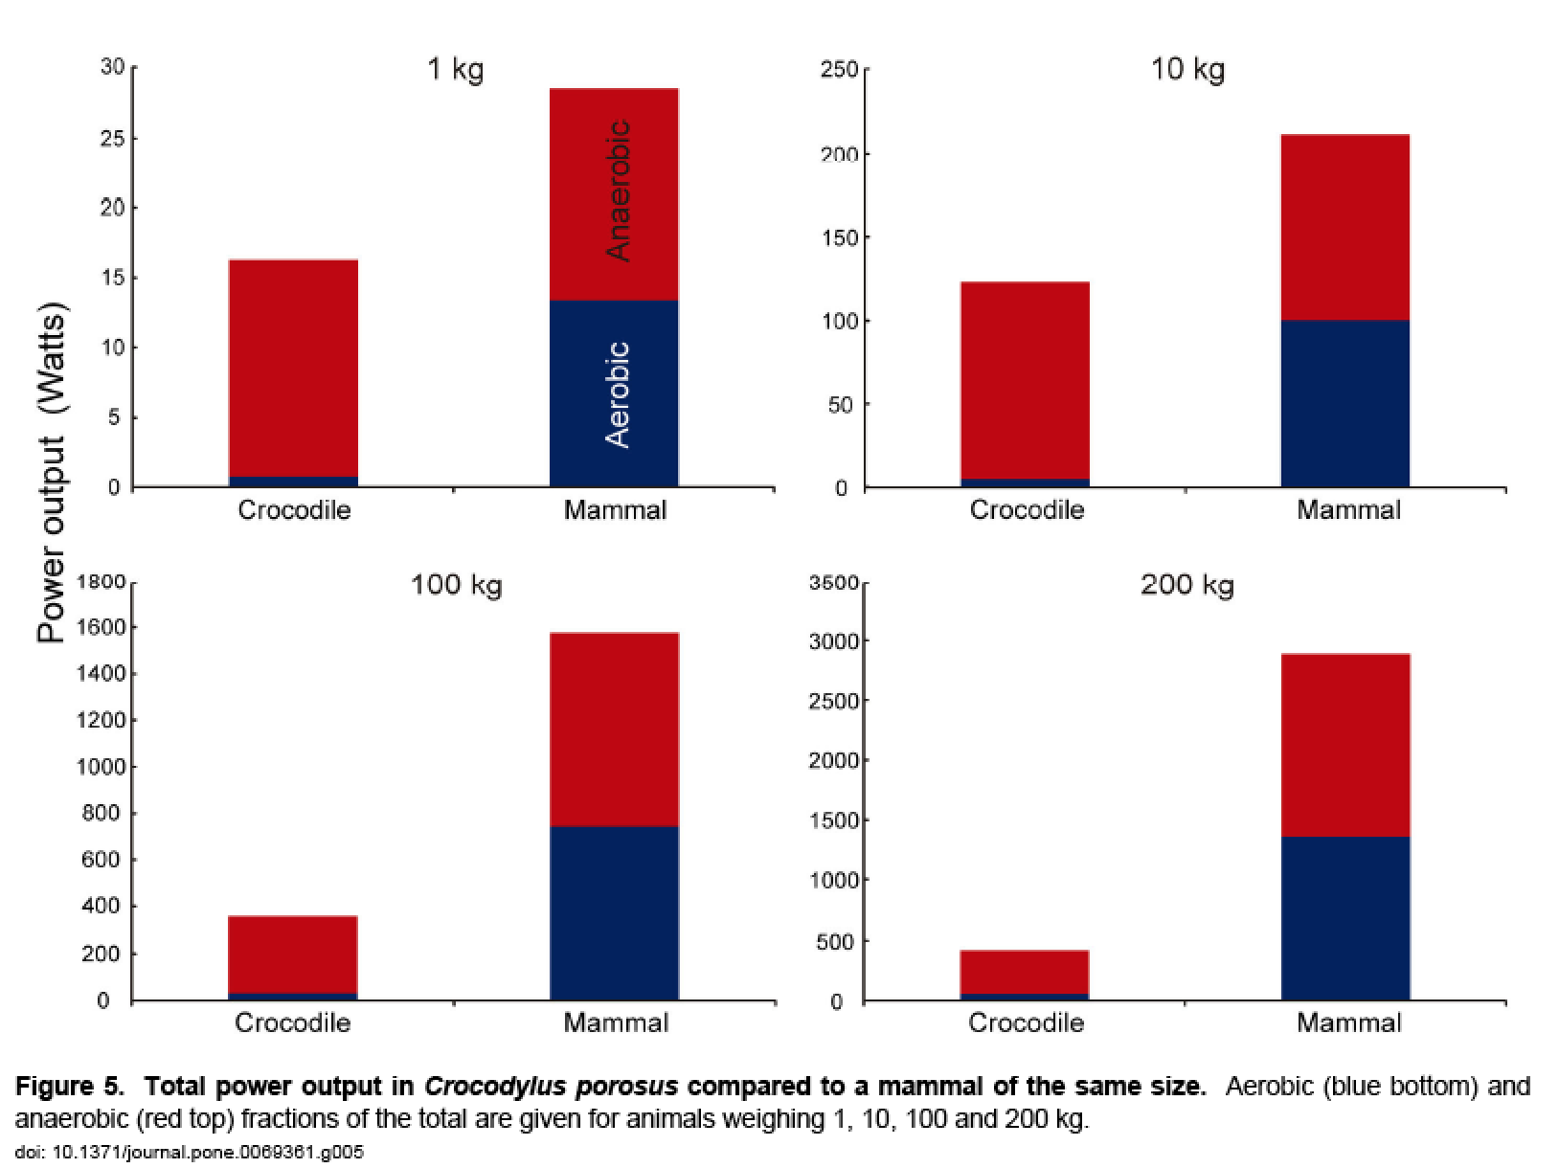

9. What can you conclude about the power achievable by a crocodile able to maintain a body temperature above 30°C versus a mammal that can maintain a stable temperature at 38°C?

10. What is the difference between a standard and basal metabolic rate?

Look at this figure summarizing the power data on the crocodiles and mammals, scaled to larger body sizes like you might see in dinosaurs (Seymour 2013):
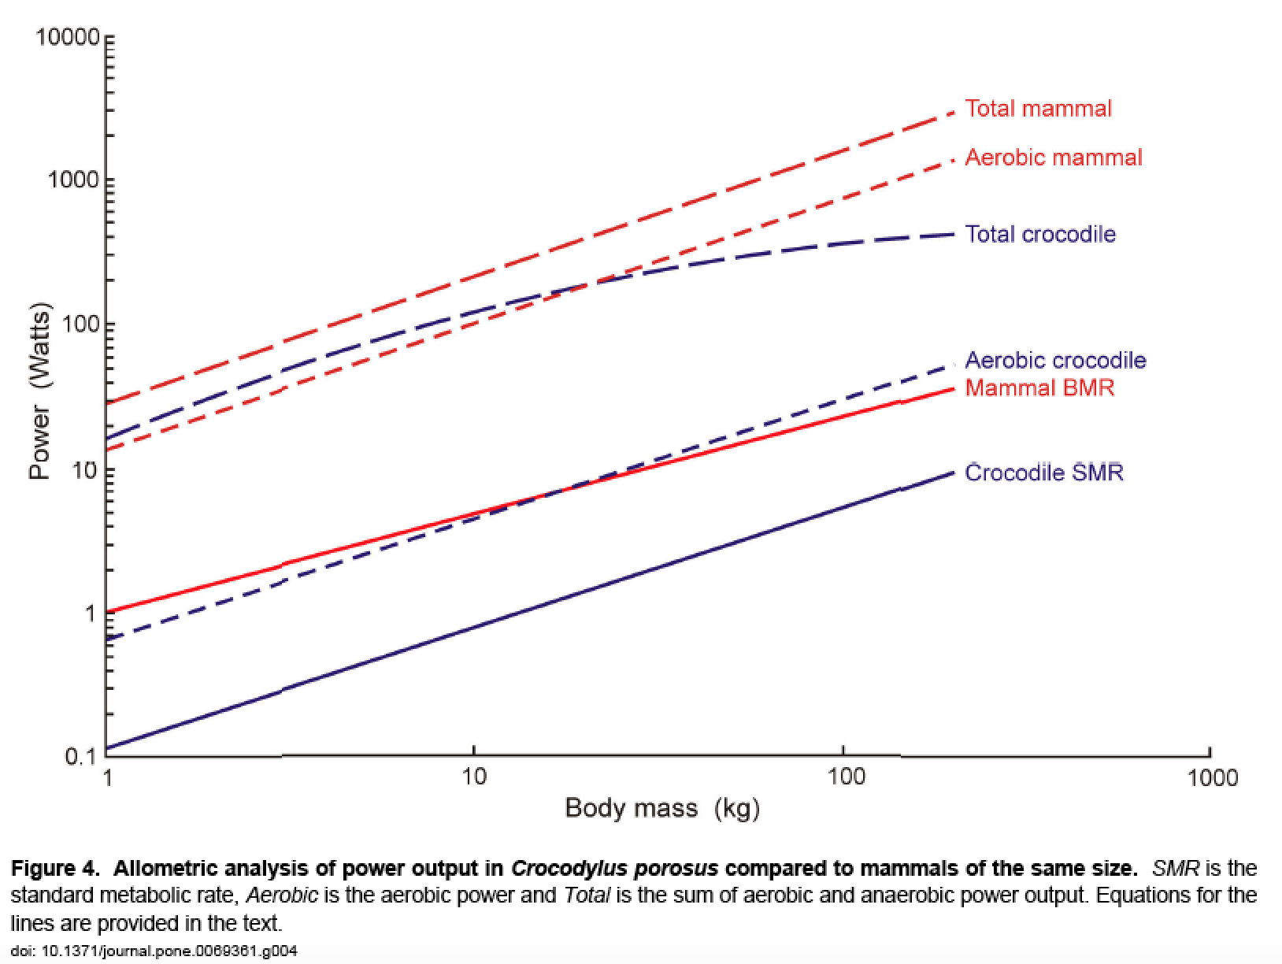

11. Can you think of a large reptile that chases down its prey in the way of, say a cat? If dinosaurs were physiologically similar to crocodiles, who do you think would likely “win” in a battle between a dinosaur and a mammal? Why?

