CHAPTER 3 EGYPT AND THE BRONZE AGE (5000–1200 BCE)

Type: multiple choice question
Title: Chapter 03 Question 01
1. The Nile delta is found in _______.
Feedback: Page Reference: (p. 78)
a. Nubia
b. Kush
*c. Lower Egypt
d. Upper Egypt

Type: multiple choice question
Title: Chapter 03 Question 02
2. What does the word “pharaoh” mean in Egyptian?
Feedback: Page Reference: (p. 78)
a. “Tallest Man”
b. “Supreme Ruler”
c. “God in Man”
*d. “Great House”

Type: multiple response question
Title: Chapter 03 Question 03
3. Which of the following are among the early Egyptian cultures in the Nile delta?
Feedback: Page Reference: (p. 81)
*a. Merimde Culture
*b. Maadi Culture
c. Siwa Culture
d. Gazi Culture

Type: multiple choice question
Title: Chapter 03 Question 04
4. What is faience?
Feedback: Page Reference: (p. 82)
*a. A lustrous ceramic made from crushed quartz and copper pigments
b. The word used to denote the divine authority of the pharaoh
c. An irrigation technique pioneered in the Nile delta around 2500 BCE
d. The kind of stone on which Rosetta inscription is written

Type: multiple choice question
Title: Chapter 03 Question 05
5. Egyptians wrote on ______, which was made from a type of bulrush that grew along the Nile.
Feedback: Page Reference: (p. 85)
a. vellum
*b. papyrus
c. cane
d. terra cotta

Type: multiple choice question
Title: Chapter 03 Question 06
6. What did the Egyptians call their land in their own language?
Feedback: Page Reference: (p. 89)
a. Ptah
*b. Kemet
c. Saqqara
d. Ma’at

Type: multiple choice question
Title: Chapter 03 Question 07
7. Egyptian optimism was grounded in _______, a divinely mandated order, stability, and justice in the world.
Feedback: Page Reference: (p. 91)
a. Aton
b. Uraeus
*c. Ma’at
d. Ra-amon

Type: multiple choice question
Title: Chapter 03 Question 08
8. Which of the following is generally regarded as the Golden Age of pyramid building?
Feedback: Page Reference: (p. 93)
*a. The Fourth Dynasty
b. The First Dynasty
c. The Tenth Dynasty
d. The Twelfth Dynasty

Type: multiple choice question
Title: Chapter 03 Question 09
9. Who was said to have been the last pharaoh of the Sixth Dynasty, and the first woman to rule over Egypt?
Feedback: Page Reference: (p. 95)
a. Nefertiti
*b. Nitocris
c. Cleopatra VII
d. Anck-su-namun

Type: multiple choice question
Title: Chapter 03 Question 10
10. Osiris’ brother _______ suffocated Osiris and then chopped him into pieces, which he scattered around Egypt.
Feedback: Page Reference: (p. 98)
a. Atum
b. Anubis
c. Nut
*d. Set

Type: multiple choice question
Title: Chapter 03 Question 11
11. What is the name of the collection of spells that was wrapped around a mummy?
Feedback: Page Reference: (p. 100)
a. “The Spells of Ra”
b. “The Tale of Sinuhe”
*c. “Book of the Dead”
d. “Osiris Among the Shades”

Type: multiple choice question
Title: Chapter 03 Question 12
12. Egypt suffered the first foreign invasion in its history at the hands of the _______.
Feedback: Page Reference: (p. 102)
*a. Hyksos
b. Neo-Babylonians
c. Romans
d. Assyrians

Type: multiple choice question
Title: Chapter 03 Question 13
13. In the New Kingdom, the pharaoh assumed what new role?
Feedback: Page Reference: (p. 103)
a. Supreme priest
*b. Military leader
c. “Lord of the Living and the Dead”
d. “Brother of Ra”

Type: multiple choice question
Title: Chapter 03 Question 14
14. Which New Kingdom pharaoh created an Egyptian empire?
Feedback: Page Reference: (p. 104)
a. Ramses II
b. Tut-ankh-amon (“King Tut”)
c. Akhenaton
*d. Thutmose III

Type: multiple choice question
Title: Chapter 03 Question 15
15. The pharaoh Amenhotep IV was especially devoted to which god?
Feedback: Page Reference: (p. 105)
a. Set
b. Osiris
c. Isis
*d. Aton

Type: multiple choice question
Title: Chapter 03 Question 16
16. The revival of which empire occurred during the reign of the pharaoh Akhenaton?
Feedback: Page Reference: (p. 105)
a. The Kassites
b. The Sumerians
*c. The Hittites
d. The Hurrians

Type: multiple choice question
Title: Chapter 03 Question 17
17. Which New Kingdom pharaoh is regarded as the greatest warrior pharaoh?
Feedback: Page Reference: (p. 107)
*a. Ramses II
b. Akhenaton
c. Tut-anhk-amon (“King Tut”)
d. Hatshepsut

Type: multiple choice question
Title: Chapter 03 Question 18
18. Which battle in 1274 BCE between the Egyptians and the Hittites was probably the greatest chariot battle of all time, and ended with both sides declaring victory?
Feedback: Page Reference: (p. 108)
a. The Battle of Thebes
b. The Battle of Megiddo
c. The Battle of Assur
*d. The Battle of Kadesh

Type: multiple response question
Title: Chapter 03 Question 19
19. The Egyptian empire expanded by laying claim to which two territories on this map?

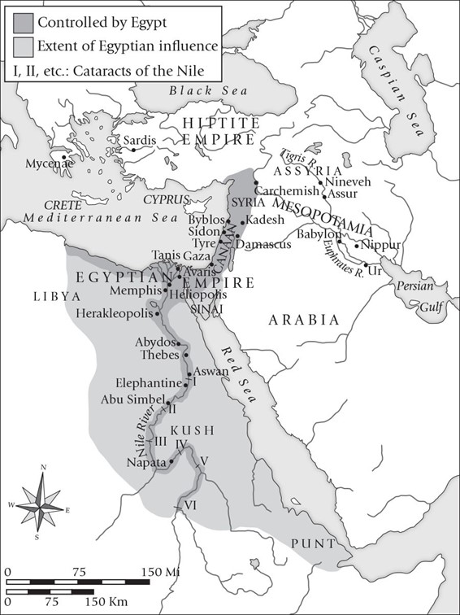

Feedback: Page Reference: (p. 104)
*a. Syria
b. Punt
c. Kush
*d. Canaan

Type: multiple choice question
Title: Chapter 03 Question 20
20. What is the name of this structure?

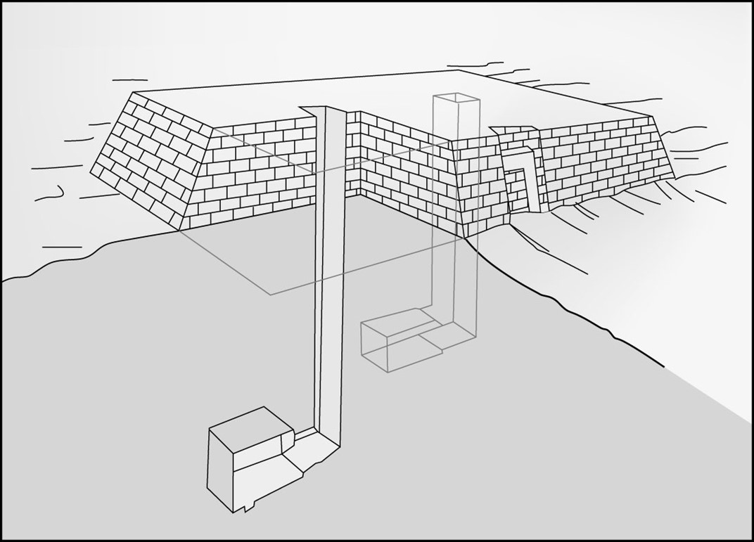

Feedback: Page Reference: (p. 82)
a. ziggurat
b. pyramid
*c. mastaba
d. akh

