Active Learning Exercise 15.1
to accompany
Vertebrate Life, Tenth Edition
Pough • Janis

Ectothermal Temperature Regulation: Some Examples
Sharon L. Gilman
Coastal Carolina University
sgilman@coastal.edu

Sources: This activity is based on the following papers:

Corkery, I, BD Bell, and NJ Nelson. 2014. Investigating kleptothermy: a reptile-seabird association with thermal benefits. Physiological and Biochemical Zoology 87: 216–221.
https://www.journals.uchicago.edu/doi/abs/10.1086/674566

Harvey, DS and PJ Weatherhead. 2010. Habitat selection as the mechanism for thermoregulation in a northern population of massasauga rattlesnakes (Sistrurus catenatus). Ecoscience 17: 411–419.
https://doi.org/10.2980/17-4-3363

Marek, V. and L Gvozdik. 2012. The insensitivity of thermal preferences to various thermal gradient profiles in newts. Journal of Ethology 30: 35–41.
https://link.springer.com/article/10.1007/s10164-011-0287-8

Ward, AJW, EMA Hensor, MM Webster, and PJB Hart. 2010. Behavioral thermoregulation in two freshwater fish species. Journal of Fish Biology 76: 2287–2298.
http://onlinelibrary.wiley.com/doi/10.1111/j.1095-8649.2010.02576.x/full

Activity

Ectotherms cannot make their own heat metabolically and do not have the insulation that endotherms typically do, but they still have an optimal temperature range at which they function best. How do they maintain that? You’re going to look at several different kinds of ectotherms and figure that out.

First, the optimal temperature ranges of very different animals tend to be fairly similar. Why is this?

You’re first going to look at two species of freshwater fish: three-spine stickleback, Gasterosteus aculeatus, and minnows, Phoxinus phoxinus. These data are from adults and juveniles in simple aquaria. The experiment looked at the positioning of the fish in aquaria with and without a thermal gradient. The results are shown below in Figure 1 from Ward et al. (2010).

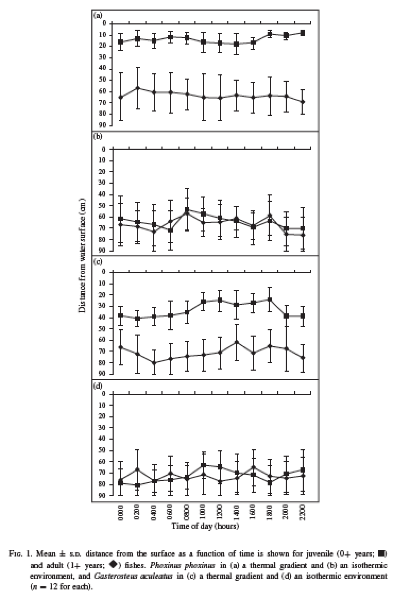

Note that the differences between adults and juveniles in graphs a and c are statistically significant, and the same pattern was there when they were housed together and apart.

1. Describe these data. What patterns do you see?

2. Suggest an explanation for the patterns. Consider what is different between adults and juveniles.

Next you’ll look at the amphibian alpine newt, Ichthyosaura alpestris. (Don’t you like that genus? Fishy lizard!).

An alpine amphibian might be expected to face particular thermoregulatory challenges, and in this paper, Marek and Gvozdik (2011) raise another interesting issue. Most studies of thermoregulatory behavior are conducted in a lab environment (like the fish study you just looked at). In these studies, the animals tend to use their environment to maintain their body temperature in a fairly narrow range within the options offered. These authors suggest that these results may be misleading and may not represent how the animals actually behave in vivo.

3. Do you agree? Why or why not?

[Note: There are other things going on in the real world: diving costs, looking for prey, avoiding predators, digesting. These might all influence where an animal could hang out and so might affect its temperature.]

4. Newts are small, aquatic, and breathe air. How might each of these three characteristics impact their ability to thermoregulate?

[Note: High surface/volume ratios allow rapid heating/cooling. Water conducts heat well, so the newts would have a hard time maintaining a temperature different from the water. They need to surface to breathe which takes energy if they are deep.]

The experimental set up consisted of a tank with a temperature gradient established either vertically or horizontally. The newts were fed to satiation and then introduced, and after an acclimation period, their body position was recorded over a 12-hour light period (when newts are active).

5. Describe a good control for this experiment.

[Note: Same set-up with no temperature gradient.]

Table 1 from the same study (Marek and Gvozdik 2012) reports on the actual body temperatures of the newts in the two experimental regimes.

6. What do these data tell you?

Consider the results in Figure 2 from Marek and Gvozdik (2012).

7. Summarize the data. What did they find? (Be sure to consider the control too!)

8. What do you think?

The authors conclude that while it does appear that newts consistently thermoregulate by choosing their position in the water temperature gradient horizontally and vertically(so depth in this case didn’t make a difference to them), they also show that a control needs to be done in these studies.

9. Why?

[Note: The newts are not randomly distributed in the control, like you would expect, so they are not choosing their position based solely on temperature, evidently.]

You’ve seen that these aquatic animals thermoregulate primarily by seeking out water of their preferred temperature. Terrestrial animals have more options. Consider the massasauga rattlesnake, Sistrurus catenatus, in its northernmost range of Ontario, Canada. They move around in the forest and clearings to bask in the sun and hiding in the shade in order to thermoregulate. The researchers (Harvey and Weatherhead 2010) make the point that it’s all fine and good to determine optimal temperatures for animals, but the reality is that often they are not able to achieve optimal, and yet they survive. This snake’s optimal temperature is 30.0°–33.0°C. Based on the likelihood of a snake to change location at the various temperatures, they developed the following descriptions:

Favorable: 30.0°–33.0°C
Challenging: <30.0°C but above or equal to 19.9°C
Constraining: <19.9°C

10. What is the overall challenge for the snakes in this habitat? Why do you think they focused just on temperatures lower than optimal?

Figure 2 from Harvey and Weatherhead (2010) might help you see the answer to this.

11. When do these snakes hibernate?

Figure 4 from Harvey and Weatherhead (2010) shows the basking patterns for these snakes.

12. Of the three plots, which one is most different? Why do you think that is?

13. Do you see changes seasonally? Why might that be?

This study found that in spring and fall, male and non-gravid female snakes were frequently at temperatures too low for movement, prey capture, digestion, and other functions. This reduced their active season from 6 months to 4 months. Gravid females thermoregulate to achieve functional temperatures for the full six months. Consider costs and benefits.

14. Why do the different groups behave differently? Why is this snake limited to latitudes from northern Ontario southward?

Finally, there is the unusual case of the tuatara, Sphenodon punctatus. This animal engages in kleptothermy! They live or rocky coasts of New Zealand, and on Stephens Island, and are close associates of a petrel (a small seabird) called the fairy prion, Pachyptila turtur. In fact, the two species share burrows. The question the researchers (Corkery et al. 2014) set out to answer is: do seabirds provide thermal benefits for tuatara?

15. First, if this were your question to answer, what would you do? Design an experiment.

Probably your design is much like in this paper, examining temperatures of tuatara in burrows with and without birds (the tuatara do not exclusively use burrows containing birds). Remember that in the southern hemisphere October is spring and January is summer. Tuatara have a preferred body temperature of 19.5°–23.1°C.

16. What do these data suggest?

See Figure 2 from Corkery et al. (2014). The authors speculate that this source of heat, while not necessary for the tuatara, may provide fitness advantages.

17. Explain that.

18. And if it’s all good, why don’t all the tuatara live in a prion burrow? What do you think happens in the winter when the birds aren’t there?

Bonus: Can you think of another example of interspecific kleptothermy? What about intraspecific?

