Active Learning Exercise 10.1
to accompany
Vertebrate Life, Tenth Edition
Pough • Janis

A Fossil Update to the Transition from Fish to Tetrapods
by Sharon L. Gilman
Coastal Carolina University
sgilman@coastal.edu

Source: This activity is based on the following paper:

Ahlberg, P. E., and J. A. Clack. 2006. Palaeontology: A firm step from water to land. Nature 440: 747–749. doi:10.1038/440747a

Level of Difficulty: Difficult

Relevant Terminology: transitional form, outgroup, crown group, cladogram, derived characteristics

Activity

Part I

Answer the following three questions based on reading the paper above.

1. In the discussion of why Tiktaalik is important, this editorial suggests that it demonstrates the predictive capacity of paleontology. What does that mean and how does Tiktaalik do that?

2. What specific traits make Tiktaalik a “transitional form”? Explain.

3. Suppose you are a paleontologist specializing in the transition from fish to tetrapods. Obviously Tiktaalik was a big deal and you want to find the next big deal. What are a few specific traits you’re looking for in the next important fish → tetrapod animal to advance what’s now known about this process? In which geologic time periods will you look?

Part II

This table shows the states of nine morphological characters for a variety of sarcopterygian fishes.

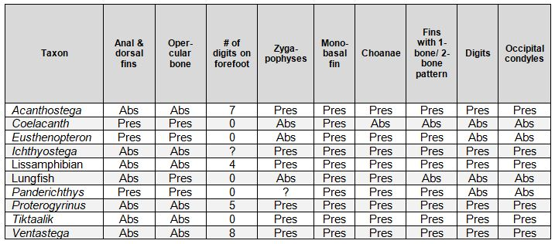

1. Use coelacanths as the ancestral outgroup and lissamphibians as the crown group to determine the phylogenetic position of the intervening species. Draw a simplified cladogram based on textbook Figure 10.2 and indicate the appearance of derived characters.

2. Estimate the approximate date (mya) of the major extant group branches on your cladogram.

3. For each of those branches, indicate a derived characteristic or two that identifies it.

Additional Resource/Link

Meet Tiktaalik roseae: An Extraordinary Fossil Fish
http://tiktaalik.uchicago.edu/meetTik2.html

