Active Learning Exercise 7.1
to accompany
Vertebrate Life, Tenth Edition
Pough • Janis

Sharks and Trophic Cascades
by Sharon L. Gilman
Coastal Carolina University
sgilman@coastal.edu

Sources: This activity is based on the following papers:

Ferretti, Francesco, Boris Worm, Gregory L. Britten, Michael R. Heithaus, and Heike K. Lotze. 2010. Patterns and ecosystem consequences of shark declines in the ocean. Ecology Letters 13: 1055–1071. https://doi.org/10.1111/j.1461-0248.2010.01489.x

Roff, George and 8 others. 2016. The ecological role of sharks on coral reefs. Trends in Ecology & Evolution 31(5): 395–407. https://doi.org/10.1016/j.tree.2016.02.014

Level of Difficulty: Medium

Relevant Terminology: trophic cascades, apex predators, mesopredators, teleosts

Introduction

Below are figures from the papers, accompanied by short exercises designed to enhance your understanding of trophic cascades.

Activity

John Muir, founder of the Sierra Club, famously said, “When we try to pick out anything by itself, we find it hitched to everything else in the universe.” This certainly applies to ecosystems. Everything is connected.

- Describe an example illustrating this.

One example you might have chosen is a trophic cascade. Do you remember those from ecology?

- Generally speaking, what is a trophic cascade?

Consider Figure 7 from Ferretti et al. (2010).

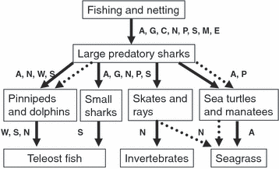

The letters indicate regions where the particular interactions have been documented, as follows: A, Australia; C, Caribbean; E, Europe; G, Gulf of Mexico; M, Mediterranean Sea; N, North American East Coast; P, Central Pacific; S, South Africa; W, North American West Coast.

- What ecosystem is this figure describing?

- The dotted arrows indicate behavioral interactions. What do you think the solid arrows indicate?

- Consider each trophic level. If fishing and netting were successful over time, what do you predict would happen to the biomass of each trophic level? Indicate with an up or down arrow next to that level.

Your arrows in the previous question indicate a trophic cascade caused by the removal of the big sharks.

- What evidence would you need to confirm this?

Here is Figure 6 from Ferretti et al. (2010) showing data from inshore waters of Kwa-Zulu Natal, South Africa over two periods of time, as indicated on the y-axes.

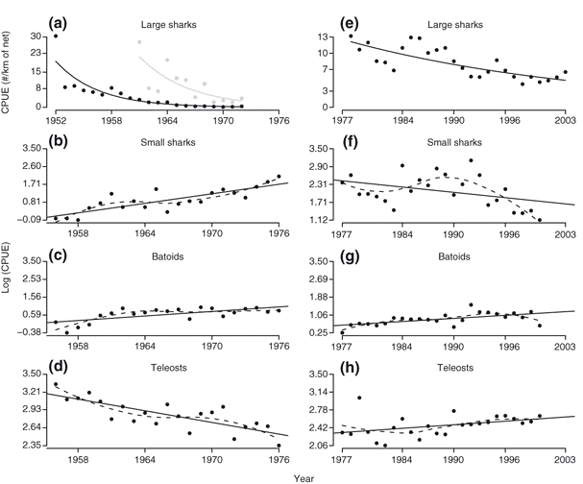

CPUE is a fisheries measurement—catch per unit effort.

- What does a decreasing CPUE indicate about a fish population?

Notice the change in scale on the y-axis for the large sharks plots. In both cases, the CPUE for the large sharks declined over time.

- Why do you think there was such a dramatic drop from the early to the later data set?

- Do you think the earlier data set suggests a trophic cascade? Explain.

- Do those same patterns hold for the later data set? Explain.

By graph (h) it looks like the teleosts are recovering, despite the increase in the batoids which seemed to result in a decline in teleosts in the earlier time period.

- Why might teleosts be able to recover from a population decline when the chondrichthyes evidently can’t?

Evidence like this supporting a shark-driven trophic cascade has been found in some marine ecosystems, but not all of them. For example, there is some controversy over whether this happens in coral reefs. Roff et al. (2016) point out that even our “historical” baselines in coastal habitats like coral reefs might have already been depleted of sharks by the time we started looking, and so the influence of those top predators is less obvious than it might otherwise be.

But they also introduce another confounding issue. Look at this figure from their paper.

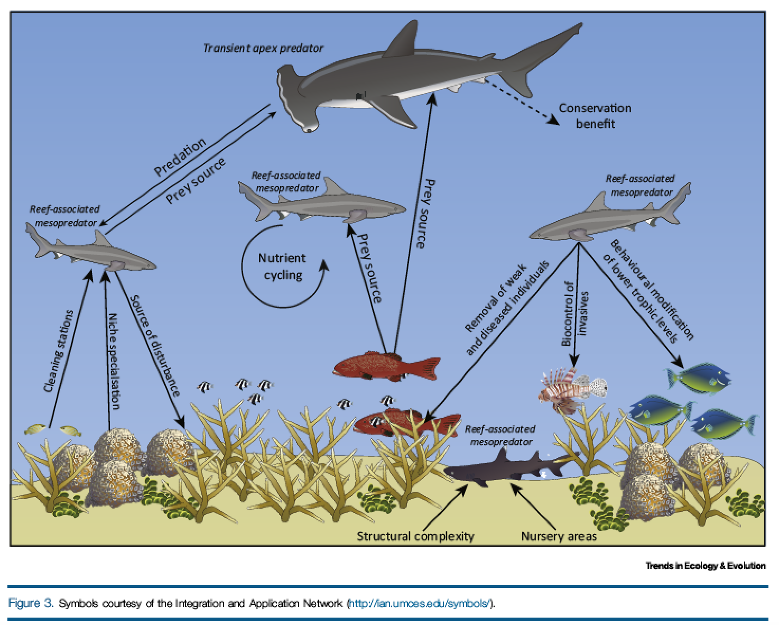

This time the arrows don’t indicate just energy flow.

- What do they indicate, and how are they different than the “top-down” influence that might be expected if shark removal causes a trophic cascade?

- What does this figure suggest about the relationship between sharks and reefs?

Roff et al. suggest that the mesopredators (small sharks/big teleosts) adequately fill the predator role for the reef when the bigger sharks are removed, but it’s not just that the mesopredators remove the smaller fish.

- What other influence might they have on smaller fish that would, in turn, affect the structure of the reef?

